
DESIGN AND IMPLEMENTATION OF FINAL YEAR REPOSITORY SYSTEM FOR NILE UNIVERSITY OF NIGERIA SOFTWARE ENGINEERING DEPARTMENT

BY
ADEMOLA ABDULSAMAD AFOLABI 20232247
OBINNA MMAJU
AISHA JAMIL
CHIELOKA EZEKWU
MASTURA ZULKIFILU
MICHAEL ORDU
SUPERVISOR: DR BILKISU LARAI MUHAMMAD-BELLO
A PROJECT SUBMITTED TO THE DEPARTMENT OF SOFTWARE ENGINEERING, FACULTY OF COMPUTING, NILE UNIVERSITY OF NIGERIA, IN PARTIAL FULFILMENT OF THE REQUIREMENTS FOR THE AWARD OF DEGREE OF BACHELOR OF SCIENCE IN SOFTWARE ENGINEERING, NILE UNIVERSITY OF NIGERIA.

JUNE, 2026

DEDICATION
We dedicate this piece to our parents and guardians that acted as the pillars for our academic life with their continuous support and we hope to make all their prayers and sacrifices not be in vain.
We also dedicate this to Nile University of Nigeria to keep the flow of technology moving, and further promoting such projects at the end of all students events.

ACKNOWLEDGEMENT
We thank God for His grace and support uptill now, truly without Him nothing is possible and there is nothing he can not do.
We are grateful to our supervisor, Dr. Bilkisu Larai Muhammad-Bello for making time even when we did not always deserve it and for always being giving us insights on our deliverables no matter how bad it may have turned out. Her input for very integral to the outcome of this project.
We also give gratitude to Nile University of Nigeria for providing us with the necessities and lecturers who never saw things one way and always gave a chance in scenarios where redemption was needed.

ABSTRACT
The Faculty of Computing at Nile University currently manages final year projects through physical archives or direct inquiries to supervisors, a manual process that limits accessibility and risks data loss. This project addresses these inefficiencies by developing a web-based repository to centralize, secure, and streamline project management. Built using React, Node.js, and PostgreSQL, the platform provides a structured environment for archiving research while maintaining intellectual property control through a three-tier access model for students, staff, and administrators.

Students use the system to search and filter past works by year, tags, or supervisors, viewing basic project details such as titles and abstracts. To access restricted artifacts like source code or full documentation, students must submit a digital request to the project supervisor or an administrator if the staff member is no longer with the institution. Additionally, the platform digitizes the submission workflow, allowing students to upload their work for supervisor validation before official publication. By utilizing Cloudinary for the cloud storage of PDFs and raw files, this solution replaces the faculty's current physical system with a searchable, transparent, and scalable digital archive.

CHAPTER ONE 3
INTRODUCTION 3
1.1 Background of the Study 3
1.2 Statement of the Problem 4
1.3 Aim & Objectives 4
1.4 Significance of the Study 4
1.5 Scope and Limitation of the study 4
1.6 Organization of the Study 5
1.7 Definition of Operational Terms 5
CHAPTER TWO 5
2.1 General Information 5
2.2 Related Works 6
2.3 Summary of the Review 6
CHAPTER THREE 15
3.1 System Analysis 15
3.1.1 Analysis of the Existing System 15
3.1.2 Limitation of Existing System 16
3.1.3 Justification of the New System 16
3.1.4 Description of the New System 16
3.2 Design of the Proposed System 17
3.2.1 Data Model 17
3.2.2 Functional Requirement 19
3.2.3 System Architecture 20
3.2.4 Software Structure 21
3.2.5 Workflow of Use Cases 23
3.3 Data Collection 24

References 24

CHAPTER ONE

INTRODUCTION
This project aims to digitize Nile University of Nigeria’s final year access system. This chapter will explain the background of study, the problem statement, aims and objectives, scope and limitations, and the definition of project terms.

1.1 Background of the Study
The Final Year Project is what students work on at the end of their time at university. It is like a project that shows what they have learned. The Final Year Project helps students use what they learned in class in life. This project is very important for students who are studying at university for students in the Faculty of Computing. The Final Year Project is a part of what students have to do. In the Faculty of Computing students have to show that they are good at using computers and can solve problems on their own. They also have to be able to do research by themselves. The Final Year Project is a deal because it helps students get ready for the real world. These projects produce a lot of ideas and information. This can be things like software and formulas or detailed reports about what we have learned. All of this information helps our institution learn and grow. We get to add it to what we know. The projects really help our institution because they give us knowledge, about software applications and algorithms and other things.

The management of these projects has always been done in an old fashioned way. Students give their supervisors and the department actual paper copies of their reports. These papers are then kept in libraries or special storage rooms. This way of doing things has worked okay so far.. It is getting really old now that everything is going digital.

The problem with keeping papers is that they do not last forever. They get. Destroyed over time. We also need a lot of space to store them. The biggest problem is that it is very hard to find the information we need when we need it. The management of these projects and the students reports are suffering because of this.

When students want to look at projects for reference or to do some reading it is really hard to do that with the system we have now. Students who want to get some help or ideas from projects often have a tough time because the library is not open all the time or they cannot find the papers they need or they just cannot search for what they want easily. This makes it very hard for students to get to the information they need. As a result students often end up doing the work that someone else has already done instead of using that work to do something new. This happens because past projects are not easy to access so students do not know what has already been done. Past projects are, like a treasure trove of information. Students cannot get to that information easily so they just do the same thing over again. Furthermore, the absence of a centralized digital backup puts this intellectual property at risk of permanent loss due to potential hazards like fire, flooding, or simple mismanagement.

1.2 Statement of the Problem
The lack of an accessible vault for final-year projects, which hinders students from effectively viewing previous topics and artifacts, is a problem that our project directly addresses. Students are unable to properly conduct research, avoid duplication, and effectively build upon existing knowledge within the institution due to the lack of a central repository, which forces them to rely on fragmented, informal methods to find previous work.
Additionally, we tackle the crucial issue of irreversible project loss. A significant amount of important academic work is only kept on supervisors' personal computers or in susceptible hardcopies, where it is constantly in danger of being lost due to hardware malfunctions, physical damage, or problems with data migration. The irreversible deterioration of our institution's intellectual output and student innovation is ensured by this storage method.
[10] Abdulkareem Okadigbo attempted to solve this issue with a platform which leaned more towards a research sharing platform that allowed researchers also come together to discuss projects making it not centralized to nile university.

1.3 Aim & Objectives
This Project’s aim is to implement an access role based final year project repository website where projects can be viewed by students with controlled access by staff who also upload said projects.
The objectives of our projects are:
- To design a structured permission based repository system architecture which finds the balance between a projects discoverability and access control.
- To implement a functional and secure web-based repository that demonstrates core workflows for project discovery, access requests and admin management and to also implement a system which retains projects over time.
- To evaluate the systems usability and effectiveness through testing with target users to ensure key performance.

1.4 Significance of the Study
The project is significant because it grants students an easier way to review past projects and get inspiration from them as well as look for openings of innovation from projects similar to theirs. It also helps supervisors and institutions in the sense that all final year projects can be uploaded on a platform which assures them 3 different options when retrieving projects(the vault(our project), other supervisors and the printed hardcopies). It also aids in plagiarism checks because all uploaded projects would be available for download to be compared.

1.5 Scope and Limitation of the study
The scope of the project is as follows:
Students will be able to view projects and request access for the unlimited view of them. Additionally, students will be able to upload their completed projects and artifacts to a validation queue for supervisor review.
Staff uploads projects and artifacts, approve of students request to view full projects and manage existing projects
The system will be an independent website and not an extension of the portal.
The limitations of the system are:
It will be within faculty of computing.
Storage space may be limited.
Progress tracking will not be a feature of this system.

1.6 Organization of the Study
The study is organized like so:
- Chapter one: Explains the background of the subject matter and the aims, goals, scope and significance of the developed project.
- Chapter two: This is where several literatures are reviewed so our project can gather strengths and avoid weakness or sight opportunities from strengths and weaknesses.
- Chapter three: This deals with the analysis, architecture and design of the system as well as the data collection methods
- Chapter four: This showcases the implementation of the project, expressing the challenges and knowledge obtained from the development of the system.
- Chapter five: This is the summary of the document highlighting key points and providing recommendation for future works.

1.7 Definition of Operational Terms
- Student: The studying person who researches projects on the platform
- Supervisor: The staff in charge of certain student(s) projects and managing project and their artifacts.
- Repository: digital location where projects and their materials are stored.
- Artifacts: documents produce during the lifeline of the project

CHAPTER TWO

LITERATURE REVIEW
A literature review is crucial because it ensures a project is built on a proven foundation rather than reinventing the wheel. It allows researchers to analyze existing systems to gather strengths and avoid weaknesses observed in previous works. By identifying gaps, such as the lack of structured access mechanisms in current repositories, you can justify your specific innovations.

2.1 General Information
This final year project Repository system acts as a vault to retain final year projects and their artifacts which will prove to be very useful in final year students development of their individual projects.
Nile university is in need of a dedicated repository system to hold several projects over time online for ease of access, this would greatly boost researching projects for students, by simply searching the website for their required project.

2.2 Related Works
Project topic repositories are common products made quite frequently because projects are made or thought up several times every year, but each project takes different approaches in how they carry it out.
- [10]Design and Implementation of a final year project system by Abdulkareem Okadigbo, former student of Nile university, This was a similar project in the past which talked about resource sharing project for final year students and researchers alike, making use of HTML, CSS, Javascript for its frontend, PHP for its backend and MySQL for database management.

- [11]Designing and Implementation of a project management system by Muhammad Nazeer Garba This involved students uploading their projects to a platform where supervisors would validate the submission and allow other students to search. Also making use of HTML, CSS, Javascript for its frontend, PHP for its backend and MySQL for database management.

- [40]Final Year Projects Record Management system by Johnson Tunde Fakoya, Mobolaji Olusola Olarinde, Department of Computer Science, Federal Polytechnic Ile-Oluji, Nigeria, This system designs a final year project manager and repository with supervisor tracking to fully digitize and automate the submission process, making use of HTML, CSS and Javascript for tis frontend, PHP for backend and MySQL for database management.

- [12]Smart Final Year Project Archive System (SFYPAS) by MatTaib, A., Mohd Shukri, N. A., Ahmad Zukri, N. H., & Ghazali, N. They made a repository that allowed search and retrieval of projects by both undergraduates and staff while also making use of Technology Acceptance Model for evaluation. They made use of HTML, CSS, Jacascript and ajax for frontend and PHP for backend.

2.3 Summary of the Review
s/n | Title | Author  Year |  | Summary | Limitations
1 | Development of a responsive web-based Final-Year Project Repository System (FYPRS) for Nigerian Tertiary Institutions. World Journal of Advanced Engineering Technology and Sciences. | Onwuegbuzie, Innocent & Adu, Michael.  2024 |  | The paper explicitly focuses on a responsive web-based system, ensuring accessibility across devices | While the FYPRS likely allows abstract viewing, the paper does not detail a structured request-to-access mechanism.
2 | An Empirical Study of the Impact of Agile Practices on Student Performance in Software Engineering Projects. | Drury-Grogan, M. L., & O'Dwyer, T.  2021 |  | Offers quantitative data from student teams showing Agile methods lead to higher project completion rates and quality. | Focus is on students building software, not on developing repository systems.
3 | Towards for Designing Educational System Using Role-Based Access Control | Maha Kadhim Kabier1 Ali A. Yassin1 Zaid Ameen Abduljabbar1  2023 |  | Proposes a secure role based educational system that really emphasizes on security even possessing multi factor authentication | This focuses on employing RBAC to any educational system rather than specifically repositories.
4 | Development of a mobile Web library application for an institutional repository and investigation of its influences on learning | Hien  Thi Thanh Nguyen  , Wu-Yuin Hwang  ,  Thao Pham  2023 |  | The study suggests implementing an MWLA with Algolia’s search service to improve the institutional repository and enhance learners’ access to reliable information. It involved an experiment with 85 undergraduate students divided into experimental and control groups | This system gets back only empirical data.
5 | A SYSTEMATIC LITERATURE REVIEW OF USER-CENTRIC DESIGN IN DIGITAL BUSINESS SYSTEMS ENHANCING ACCESSIBILITY, ADOPTION, AND ORGANIZATIONAL IMPACT | Md Arifur Rahman  2023 |  | Presents the benefits of user centric design for design and implementation. | Focuses on user design in a business organization space
6 | DIGITAL PRESERVATION STRATEGIES FOR LONG TERM ACCESS TO ARCHIVAL RECORDS: LESSONS FROM DONALD EKONG LIBRARY, UNIVERSITY OF PORT HARCOURT | Okonkwo, David Oluchukwu1, Evelyn Iroabuchi Enwerem2, Kenneth Okwara  2023 |  | It makes use of preservation strategies to retain archives for a long time they adopted digital open formats. | It uses only one library as a case study.
7 | The use of prototypes as a tool in Agile software development | Vivian Larrea, Milene Selbach Silveira, Tiago Da Silva  2024 |  | The study provides quantitative data showing that teams using a combination of low-fidelity and high-fidelity prototypes within Agile sprints experienced a 40% reduction in major UI redesigns during later development stages | The methodology's success depends on having regular access to real users for prototype testing. In an academic setting, getting consistent, timely feedback from supervisors and peers can be an issue that the paper does not address.
8 | Impact of Open Access Repository in Higher Education Institutions | Leonard, A.,  2025 |  | The repository is not just a student tool but part of a broader academic movement towards open access, knowledge preservation, and showcasing institutional output. | It does not grapple with the complex, permission-gated access control
9 | Digital Preservation Strategies in Academic Libraries: Ensuring Long-Term Access to Scholarly Resources | Nurhidayah & Adelaide Gracegefa Purnomo  2023 |  | Provides a tiered approach specifically for academic use cases | The research focuses on university-wide systems managed by central IT departments
10 | Design and Implementation of a project management system | Okadigbo Abdulkareem  2023 |  | This is a very strong researcher tool and would give students and eventually other researchers a good way to share and monitor projects. | Students are expected to upload the project which may cause issues with lack of format and incompleteness, which is risky as an official system for nile university.
11 | Design and Implementation of student project management system | muhammad nazeer garba  2023 |  | This was a system similar to ours but with major differences being no request permission system and supervisors handle uploads. | The limitations being its reliance on students submitting the projects which takes time from supervisors having to make sure the submit it in the right format.
12 | Smart Final Year Project Archive System (SFYPAS) | MatTaib, A., Mohd Shukri, N. A., Ahmad Zukri, N. H., & Ghazali, N.  2020 |  | They used Laravel to create a Smart Final Year Project Archive System (SFYPAS) for managing and storing undergraduate project reports.The methodology stated was waterfall By minimizing topic duplication and making it simple for users to search and retrieve previous projects, the system enhances knowledge sharing. Its evaluation using the Technology Acceptance Model (TAM) revealed that staff and students thought it was easy to use and helpful, emphasizing the importance of user acceptance. | The small sample size of the study limits how broadly the results can be applied. Additionally, the system lacks sophisticated features like plagiarism detection and reliable long-term digital preservation solutions that are necessary for a thorough academic repository. These gaps point to areas that could be improved in the future to improve the functionality and sustainability of the system.
13 | Digitization of Theses and Dissertations for Institutional Repositories | Adigun, T. A., Nwokedi, G.I., Amando, A.A, Igboechesi, G.P.  2023 |  | This pushes the idea of digitization being very important in long term storage. | Lacks evaluation of the repository’s other quality attributes like automation, access control etc.
14 | Sustainability of Institutional Repository Systems | Igboechesi, G.P., Adigun, T.A., Pobish, P.S, Angulu, R.K.  2023 |  | It uses key factors to describe challenges that lead to unsustained systems while using university of jos as a case study. | It does not use any software based solutions to solve this issue.
15 | Need for Digitization of Academic Projects | Nwokoji, E.  2023 |  | This expresses the need for digitization and the impact of digitization. | Is not directly referring to a repository system.
16 | Web-Based Digital Repository Systems | Che Mohd Sakri, N. S., Wan Hussain, W. H.  2023 |  | This describes the usability and benefits of a web based repository system. | It is not exclusive to an academic system.
17 | Layered Architecture | Richard Thomas & Brae Webb  2025 |  | A system is organized into hierarchical tiers (Presentation, Business, Persistence, Database) using layered architecture, with each layer only interacting with neighboring layers through specified interfaces. This permits autonomous development and deployment, enforces modularity, and isolates changes. | Its limitations are the performance overhead from layered message chains, increased design complexity, and the risk of the structure breaking down into a disorganized "Big Ball of Mud" if its principles are not strictly followed.
18 | Prototyping to elicit user requirements for product development: Using head-mounted augmented reality when designing interactive devices | Bo Kang  , Nathan Crilly,  Weining Ning  , Per Ola Kristensson  2023 |  | The study looks at head-mounted Augmented Reality (AR) as a way to make prototypes of interactive devices to find out what users want. It finds that AR-based prototypes work just as well as traditional methods for gathering user preferences, but they offer a better, more coherent, and more engaging user experience with economic benefits. | The study utilized a particular product feature with a limited participant sample (n=12). Generalizability is restricted, and hardware discomfort or the novelty of AR may have affected outcomes. The simplified test context does not accurately represent intricate real-world situations.
19 | Measurement of key performance indicators of user experience based on software requirements | Issa Atoum  2023 |  | The literature suggests a learning model to predict the user experience before actual user interaction sometimes completely disregarding prototypes. | The limitation being its reliance on a prediction based on a small benchmark dataset which is very unreliable since user centered design is key.
20 | Optimizing PostgreSQL for High-Volume Insurance Transactions & Secure Backup and Restore Strategies for Databases | Gowtham Reddy Enjam  2023 |  | It deals with using PostgreSQL to handle high-volume insurance transactions and secure backup/restore strategies | The theory’s discussed lack any real world validation.
21 | Building Scalable and Secure Web Applications Using .NET and Microservices | Aditya S Shethiya  2025 |  | This discusses building scalable and secure websites | It specifies doing so with microservice architectures and .NET framework.
22 | Metadata Quality in Thesis Repositories | Choudhury, M. H., Salsabil, L., Jayanetti, H. R., Wu, J., Ingram, W. A., Fox, E. A.  2023 |  | Talks about the problems with searching through repositories. | The solution and review was highly reliant on the AI framework MetaEnhance.
23 | Development of a Responsive Web-Based Final-Year Project Repository System (FYPRS) – World Journal of Advanced Engineering Technology and Sciences 12(01), 454–462. | Onwuegbuzie Innocent Uzougbo & Adu Michael Kolade  2024 |  | It covers everal different works on web based final year repositories including benefits and justification with examples from other repositories.
24 | Prototype Development of Final Year Project Management System to Monitor Student’s Performance – Journal of Advanced Research in Applied Sciences and Engineering Technology | Raznida Isa, Shuhadah Othman, Adam Shukry Ali & Noraliza Azizan  2024 |  | It focueses on monitoring the otucomes of users interacting with the system | This simply states the requirement gain from prototypes and not actual features
25 | Conceptual Sustainability of Trusted Digital Repositories | Bamgbose, O. A., & Ibrahim, U.  2024 |  | Uses public universities in Nigeria to explain how a repository should be structured. | It contains real world examples but is fully conceptual.
26 | Digital Preservation of Web Resources in ETD Repositories | Phillips, M. E.  2024 |  | Enlightens readers on the importance of preserving repositories in the long term retaining academic integrity. | It does not tackle user interaction no system design.
27 | Implementation of an Electronic Theses and Dissertations Repository System | Perera, K.  2024 |  | It focuses on using online archives to make theses. | One thing that stands out is how they handled the preservation part. But it seems like the whole setup was really just for one area of study. The study does not go into much detail about how well it actually performs or if users like it.
28 | Analysis of Electronic Theses and Dissertations in Central University Repositories | Latte, A.  2024 |  | It has empirical analysis of real repository data, highlights how well archiving supports academic visibility. | It excludes system design.
29 | Institutional Repository Policies and Practices in African Universities | Obaro, G. O., & Arumuru, L  2024 |  | This tackles policy that should be noted. | It strictly refers to practices and policiies of such systems
30 | Building datasets to support information extraction and structure parsing from electronic theses and dissertations | Ingram, W. A., Wu, J., Fox, E. A., & Jayanetti, H. R.  2024 |  | This further talks on reasons why extraction is a step boosted by repositories. | It only uses document level processing techniques.
31 | Bibliometric Trends in Institutional Repository Research | Rahman, M. T., Singh, V. K., & Hassan, S. U.  2023 |  | This talks of the trends in metadata, repositories and data sharing in recent years. | Explains just the importance through trends
32 | Open Access Repository and Availability of ETDs | Aryal, S.  2023 |  | This gives us insight on what we missout from making this open access by stating the impact of open access repositories | It is not an academic system.
33 | Challenges and Benefits of IR Sustainability in Nigeria | Esse, U. C., & Haliso, Y.  2023 |  | This tackles the impact both negative and positive of trying to sustain such systems in nigeria | These challenges are related to only after submission.
34 | Open Access ETD Repositories in Nepal | Aryal, S.  2023 |  | It talks on the benefits of open access policies and how it aids students from other schools worldwide. | This is still open access meaning the gain is limited.
35 | WebDirect: A Web-based Project Repository | Sanika Chavan, Janhavi Kalwar, Mrunal Golatkar, Rasika Ransing  2023 |  | It is a resource sharing type of repository system. | This is not academic institution specific but rather built for students and researchers.
36 | Final Year Project Repository with Automated Classification Using TF-IDF | M Bakri, M Danish, M Hamiz  2023 |  | The system aims to build a project repository students can use to research and also learn about other lecturers specializations | It is theoretical.
37 | Repository Information System for the Final Assignment of the South Aceh Polytechnic | Muharratul Mina Rizky, Sabrina Ulia Mouna, M Arinal Ihsa  Jurnal Inotera  2023 |  | It talks about the author trying to design a website final year repository with a dedicated framework Laravel. | It does not include much implementation details
38 | UC CCS CAMPUSCORE: A Secure Digital Repository as Knowledge Management System | Neil Basabe, Heubert Ferolino  2024 |  | Talks about a system, campuscore, which aims to tackle the issues and challenges students and lecturers face with repositories. | It is not tailored to all students such as some with handicap.
39 | Cloud Based Student Repository System | ML Reddy, Muthyala Vengal Reddy, Nayanashree NA  2023 |  | It focuses on making a cloud based repository with its own dedicated framework | It is open source.
40 | Final Year Project Record Management System | Johnson T. Fakoya & Mobolaji O. Olarinde  2025 |  | It tackles issues in traditional project recording, digitization trends, and benefits of automation. | It was tested its prototype in one university even though there were plans of expansion beyond that university.

CHAPTER THREE

3.1 System Analysis

3.1.1 Analysis of the Existing System
In many higher institutions, the management of final year project reports is carried out through manual and partially digital approaches. Students usually submit their completed projects in printed form, sometimes alongside electronic versions saved on compact discs (CDs), flash drives, or stored on departmental computers. These project materials are commonly preserved in departmental offices or libraries for consultation by students and academic staff.
Retrieving previous project works often requires physical visits to the department, approval from relevant staff, or manual searches through files, shelves, or cabinets. In some situations, only project titles and basic details are recorded in notebooks or simple spreadsheets, while the complete project documents are not stored in a centralized or easily accessible digital system.

3.1.2 Limitation of Existing System
The project management system currently in use has a major flaw: it depends entirely on keeping paper copies. Storing final year projects as physical binders and documents puts all that important student work in serious danger of being lost forever. A single event, like a fire or a flood, could destroy them in an instant. But even without a disaster, these papers face constant smaller threats—they can be stolen, misfiled and lost, or simply fall apart from age and handling. This method of storage doesn't just make access difficult; it actively fails to protect the research. It risks erasing years of the university’s own academic history because the primary record is so fragile.
The problem doesn’t end with just keeping the projects safe, however. Actually trying to get your hands on one of these archived projects is its own major hurdle. Because everything is stored physically, the only way to view a past project is to show up in person during specific office hours and formally request it. You’re then at the mercy of a staff member’s schedule and their ability to find the right binder in what is likely a crowded storage room.

This manual request system creates a huge bottleneck. It leads to unpredictable waiting times—you might get the project in an hour, or you might have to come back another day. These delays hit hardest when you’re in a critical phase of your own work, like trying to finalize your project’s scope or build your methodology section, and you need a reference quickly. Since you can't access the archive remotely or after hours, your research momentum grinds to a halt whenever an office is closed. This dependency creates an unnecessary and frustrating barrier that works directly against what the final year project is supposed to be: a self-driven, independent research experience.

3.1.3 Justification of the New System
The new system really speeds things up when it comes to finding old projects. Students wouldnt have to waste time running around from one spot to another anymore. Instead they can just pull up the info right on their laptops and get started with research pretty fast.
That old way was so annoying because sometimes a project you need might already be out with someone else or just not back yet. It takes forever searching like that.
For supervisors it is helpful too. They could easily grab those really good examples of work to show other students. I mean set a standard or something. Not sure if thats the main point but it makes sense.

3.1.4 Description of the New System
The final year project repository is a centralized web platform designed to store and manage completed academic works for the Nile University Faculty of Computing. The system operates with three primary roles: Students, Staff (Supervisors), and Admins.
Students serve as both consumers and contributors within the system. As consumers, they can search and filter the repository by year, tags, or supervisors. While basic project data (title, description, and authors) is public, students must request permission from the project’s supervisor to view private artifacts. As contributors, students can upload their own final year projects into a validation queue. Here, Staff members (Supervisors) review the submission to ensure it strictly adheres to the faculty's formatting guidelines before it is officially published.
Staff members are responsible for uploading project materials, managing their assigned projects, and responding to student access requests. To maintain academic integrity, staff can only view the full artifacts of projects assigned to them. In instances where a supervisor has left the institution, the Admin assumes the responsibility of granting access. The Admin maintains ultimate oversight, managing all users and approving or disapproving "late-edit" requests from staff who wish to modify project data after the official deadline.
The platform is built on a modern stack of React, Node.js, and PostgreSQL, providing a seamless data flow. All project files, including PDFs and media, are securely stored and served via Cloudinary.

3.1.5 Methodology
The Prototype methodology was adopted since this would be a system that students and lecturers alike would want to depend on to get proper user feedback, the prototype would allow us see holes we would not normally observe as the makers of the system. The simplicity in understanding of the system also will be compatible to have a prototype.

3.2 Design of the Proposed System

3.2.1 Data Model
The system will be designed in such a way to easily adapt our vision, a website where staff can upload projects to share with students and have as a backup for retaining projects over time.
In figure .1 is the ER diagram of the core functionality of the site.
The Database comprises of different entities namely
USERS
Student, Supervisors and Admins
Students and Supervisors entity have their own exclusive attributes along with the attributes in the user table
PROJECTS
Project is split into Project(the main entity) and project_artifact(the weak entity, an attachment Taht holds the project files) and Tags as another weak entity holding the tags of each project e.g: react, node etc.
USERS & PROJECTS
Students request full view via full_project_requests to gain access to project artifacts which will be approved or denied by supervisor.
For uploads Students go fill in project information and send it to project_validation for supervisors to validate whereby they approve the project for upload or reject it and state the necessary changes needed.

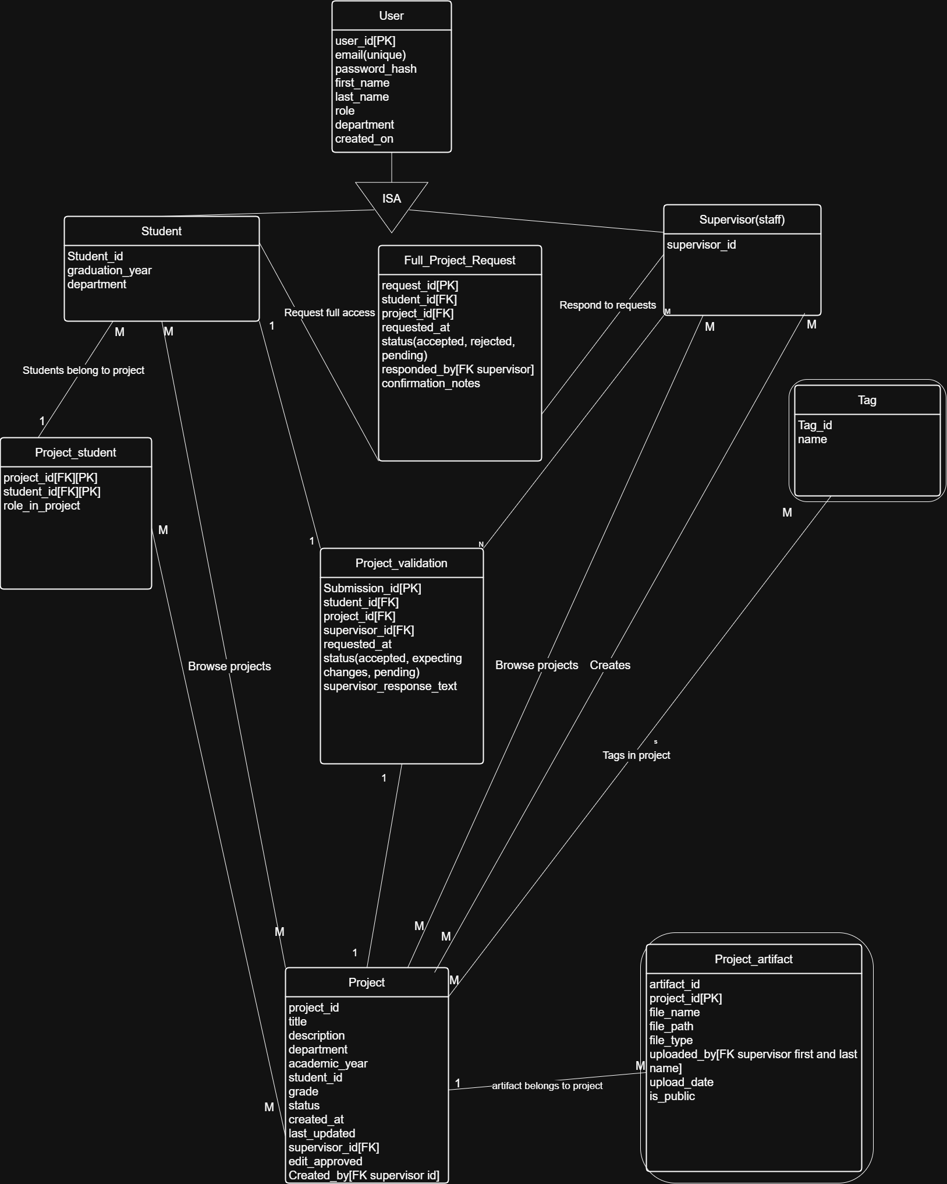
Figure 1 E.R Diagram

3.2.2 Functional Requirement
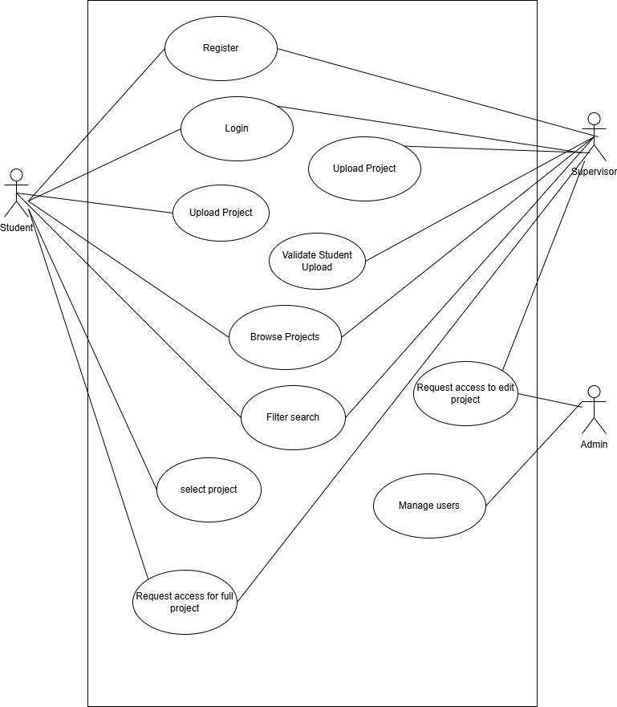
Figure 2 use case diagram
Students:
- They should be able to search for projects.
- They should be able to filter their searches.
- They should be able to view projects.
- They should be able to request permission to view full projects
- They should be able to submit their final year project for validation
Supervisors:
- They should be able to upload projects.
- They should be able to view all created projects.
- They should be able to grant student requests.
- They should be able to request edit permissions.
- They should be able to search for projects.
- They should be able to filter search.
- They should be able to validate students final year submissions.

3.2.3 System Architecture
Our selected architecture is Layered architecture because it grants a great separation of concerns for the system making it easier for scalability and maintenance as well as setting up the security.
In terms of scalability it would make expanding the system past faculty of computing vastly easier than if we used our other option being client server which would grant us better performance in an immediate sense but eventually as the scale grows concurrency of users affects both in terms of performance but can be scaled better with layered.
In figure .3 It is split into Presentation, Business, Data Access and Database layer.
PRESENTATION LAYER
This is the UI interface that users interact with like login, browse projects and so on.
BUSINESS LAYER
This handles the backend services which perform the various functions of the websites like giving the results based of user inputs such as creating projects, deleting projects, signing up, log in.
DATA ACCESS LAYER
This is the layer responsible for interactions with the database; The repositories which will handle the queries like project Creations by using INSERT , or getting all projects with SELECT this is the bridge for all our database interactions.
DATABASE LAYER
This is where our data is store using postgresql and Cloudinary for file storage of project artifacts.
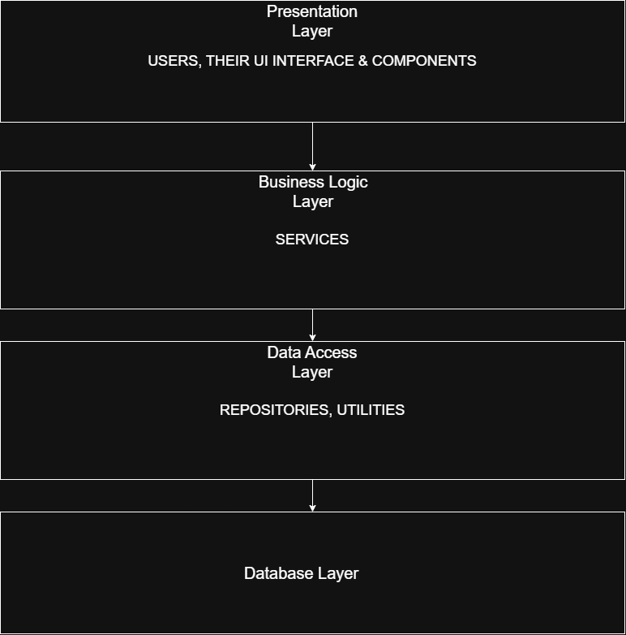
Figure 3 Layered Architecture

3.2.4 Software Structure
Below shows the deployment structure of how the system’s existence.
Users(student and supervisors) access the system via the user interface with their respective device(mobile or pc) on the frontend which will be hosted on render.
Which connects to the backend which will also be hosted on render where logic and database bits are stored. As shown in figure 4.
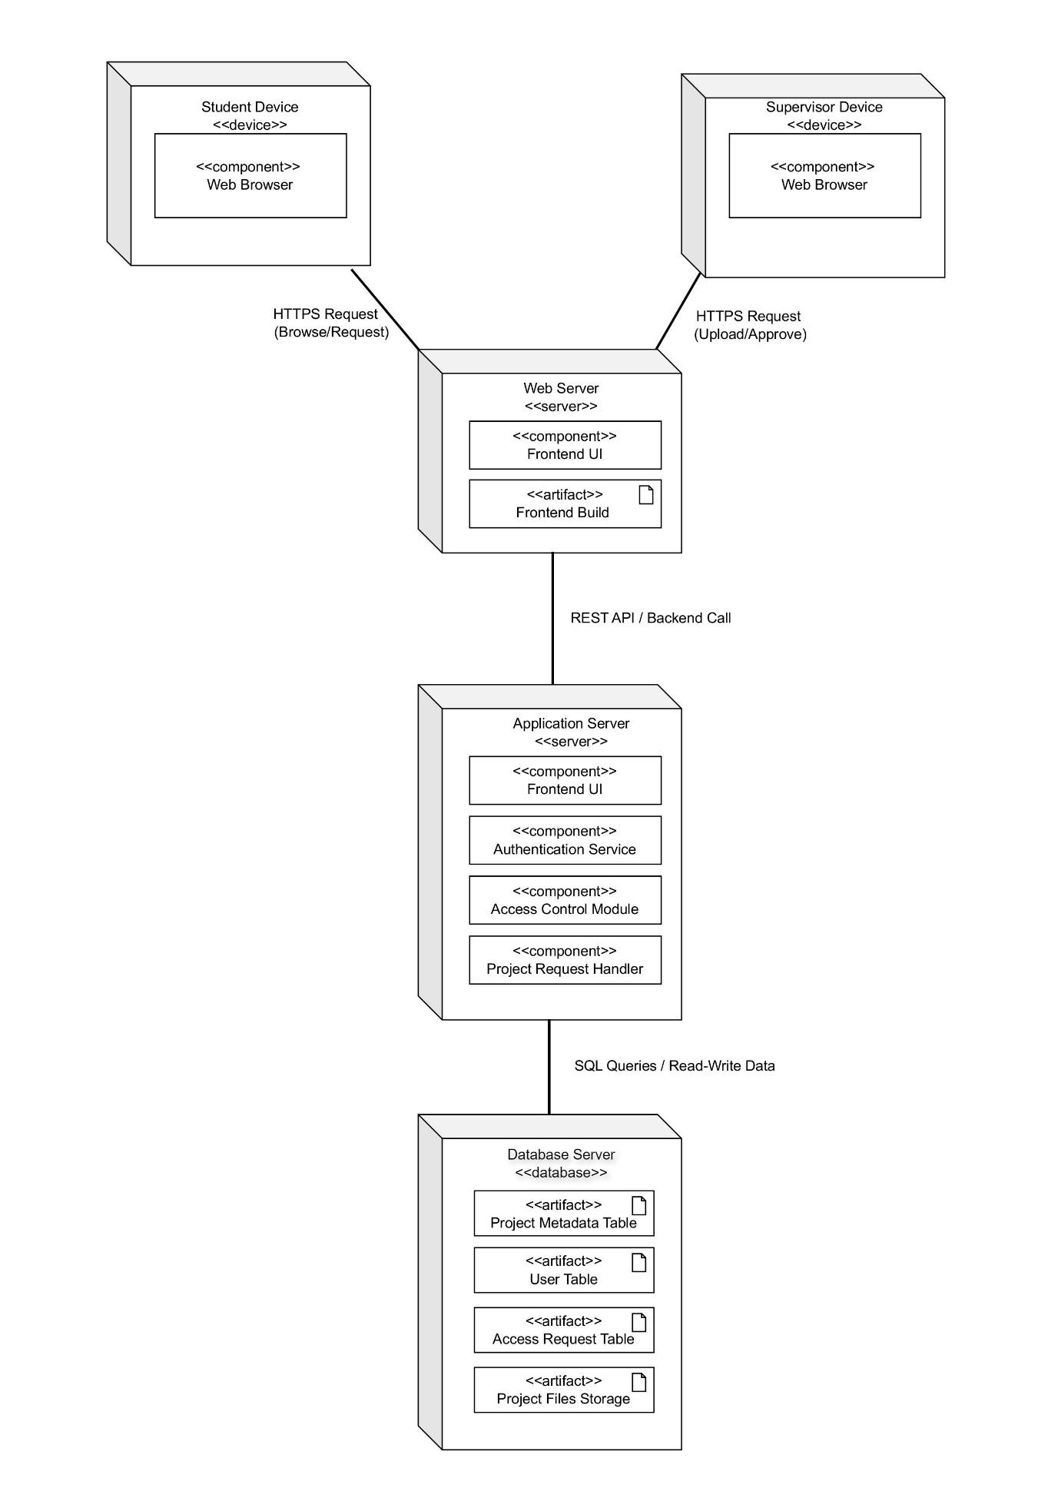Figure 4 Deployment Diagram
REACT
REACT/NODE
Postgre/Cloudinary

3.2.5 Workflow of Use Cases

In the figure below is the sequence diagram that showcases the upload process, request system and project management.
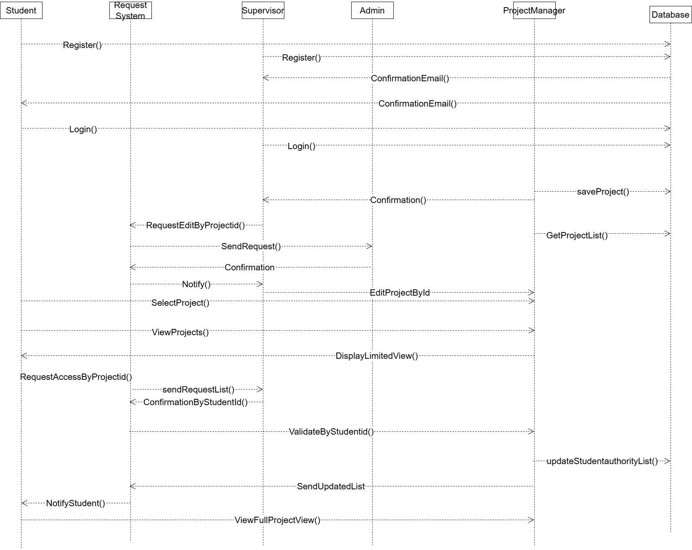Figure 5 Sequence Diagram
In Figure 5 it shows a sequence diagram that shows an order of students gaining access to past projects artifacts uploaded by supervisors(these are projects of already graduated students)
The student registers and gets a confirmation mail then logs in and can select a range of projects available then after selecting to view project it shows the student basic information like titles, names, description and then the student can request for full view which the supervisor checks in the request system and sends confirmation status(approved, rejected). And then the request system updates the list which lets student validate themselves to the project to get access to the full view if approved.

3.3 Data Collection
In our project, our data collection methods used were, Observation and interviews while also researching on the web from other similar projects.
Interviews: 2 interviews were created to gather information from supervisors and students, The supervisor interview focused mainly on the challenges supervisors face with projects and some specifics they would or would not want in the system e.g: grades in a project, and an open remark on their personal view on what the project should have.
For Students we created one to get their feedback on privacy matters and what information they would be comfortable with being shared and trying to get an estimated user experience as well as personalization settings.
Observation: We observed first hand how the current offline system is when it comes to searching for projects, some projects missing from the library, searching for supervisors to see if they still have some projects they had from long ago, we were lucky this time to not have come across a scenario where the supervisor had left the school and one or more of his supervised projects was borrowed from the library and not returned.

References
[1] Development of a responsive web-based Final-Year Project Repository System (FYPRS) for Nigerian Tertiary Institutions. World Journal of Advanced Engineering Technology and Sciences. Development of a responsive web-based Final-Year Project Repository System (FYPRS) for Nigerian Tertiary Institutions
[2] An Empirical Study of the Impact of Agile Practices on Student Performance in Software Engineering Projects.
The Impact of Agile Development Practices on Project Outcomes | MDPI
[3] Towards for Designing Educational System Using Role-Based Access Control Towards-for-Designing-Educational-System-Using-Role-Based-Access-Control.pdf
[4] Development of a mobile Web library application for an institutional repository and investigation of its influences on learning
Development of a mobile Web library application for an institutional repository and investigation of its influences on learning | The Electronic Library | Emerald Publishing
[5] A SYSTEMATIC LITERATURE REVIEW OF USER-CENTRIC DESIGN IN DIGITAL BUSINESS SYSTEMS ENHANCING ACCESSIBILITY, ADOPTION, AND ORGANIZATIONAL IMPACT A SYSTEMATIC LITERATURE REVIEW OF USER-CENTRIC DESIGN IN DIGITAL BUSINESS SYSTEMS ENHANCING ACCESSIBILITY, ADOPTION, AND ORGANIZATIONAL IMPACT | American Journal of Scholarly Research and Innovation
[6] DIGITAL PRESERVATION STRATEGIES FOR LONG TERM ACCESS TO ARCHIVAL RECORDS: LESSONS FROM DONALD EKONG LIBRARY, UNIVERSITY OF PORT HARCOURT 6.pdfhttps://jaistonline.org/16vol2/6.pdf
[7] The use of prototypes as a tool in Agile software development
The use of prototypes as a tool in Agile software development | Proceedings of the 39th ACM/SIGAPP Symposium on Applied Computing
[8] Impact of Open Access Repository in Higher Education Institutions https://www.iastatedigitalpress.com/jlsc/article/id/16936/
[9] Digital Preservation Strategies in Academic Libraries: Ensuring Long-Term Access to Scholarly Resources
Digital Preservation Strategies in Academic Libraries: Ensuring Long-Term Access to Scholarly Resources | Knowledge Garden: International Journal of Library Studies
[10]Nile University
[11]Nile university
[12] Smart Final Year Project Archive System (SFYPAS) (PDF) Smart Final Year Project Archive System Using Laravel Framework with Email Notification (SFYPAS)
[13] Digitization of Theses and Dissertations for Institutional Repositories
https://mbjlisonline.org/index.php/jlis/article/view/195
[14] Sustainability of Institutional Repository Systems
https://eajournals.org/ijliss/vol-9-issue-6-2023/sustaining-the-relevance-of-institutional-repository-in-academic-libraries-in-nigeria-a-university-of-jos-perspective/
[15] Need for Digitization of Academic Projects
https://repository.mouau.edu.ng/work/view/the-need-for-digitization-of-theses-and-dissertations-in-mouau-library-7-2
[16] Web-Based Digital Repository Systems
https://publisher.uthm.edu.my/periodicals/index.php/mari/article/view/9852 (Mari Journal)
[17] Layered Architecture layered.pdf
[18] Prototyping to elicit user requirements for product development: Using head-mounted augmented reality when designing interactive devices
Prototyping to elicit user requirements for product development: Using head-mounted augmented reality when designing interactive devices - ScienceDirect
[19] Measurement of key performance indicators of user experience based on software requirements
Measurement of key performance indicators of user experience based on software requirements - ScienceDirect
[20] Optimizing PostgreSQL for High-Volume Insurance Transactions & Secure Backup and Restore Strategies for Databases
Optimizing PostgreSQL for High-Volume Insurance Transactions & Secure Backup and Restore Strategies for Databases | International Journal of Emerging Trends in Computer Science and Information Technology
[21] Building Scalable and Secure Web Applications Using .NET and Microservices
Building Scalable and Secure Web Applications Using .NET and Microservices | Academia Nexus Journal
[22] Metadata Quality in Thesis Repositories https://arxiv.org/abs/2303.17661
[23] Development of a Responsive Web-Based Final-Year Project Repository System (FYPRS) – World Journal of Advanced Engineering Technology and Sciences 12(01), 454–462.
https://www.bing.com/search?q=Development+of+a+Responsive+Web-Based+Final-Year+Project+Repository+System+(FYPRS)+–+World+Journal+of+Advanced+Engineering+Technology+and+Sciences+12(01)%2C+454–462.&cvid=7946e8e0702b4f31ac7ac423d7875cbc&gs_lcrp=EgRlZGdlKgYIABBFGDsyBggAEEUYOzIGCAEQRRg8MgcIAhDrBxhA0gEHMzE1ajBqNKgCCLACAQ&FORM=ANAB01&PC=HCTS
[24] Prototype Development of Final Year Project Management System to Monitor Student’s Performance – Journal of Advanced Research in Applied Sciences and Engineering Technology Prototype-Development-of-Final-Year-Project-Management-System-to-Monitor-Students-Performance.pdf
[25] Conceptual Sustainability of Trusted Digital Repositories https://ijkd.uniabuja.edu.ng/index.php/ijkd/article/view/45
[26] Digital Preservation of Web Resources in ETD Repositories https://digital.library.unt.edu/ark:/67531/metadc2414108/
[27] Implementation of an Electronic Theses and Dissertations Repository System https://etd2024.unza.zm/proceedings/full-papers/papers/docs-paper-etd24-06.pdf
[28] Analysis of Electronic Theses and Dissertations in Central University Repositories https://journal.ilaindia.net/index.php/lib/article/view/348
[29] Institutional Repository Policies and Practices in African Universities https://ndltd.org/thesis-resources/manage-etds/
[30] Building datasets to support information extraction and structure parsing from electronic theses and dissertations Building datasets to support information extraction and structure parsing from electronic theses and dissertations
Building datasets to support information extraction and structure parsing from electronic theses and dissertations | International Journal on Digital Libraries | Springer Nature Link
[31] Bibliometric Trends in Institutional Repository Research https://www.researchgate.net/publication/377172049_A_Bibliometric_Analysis_of_the_Trends_and_Themes_of_Using_Institutional_Repositories_to_Manage_Research_Data
[32] Open Access Repository and Availability of ETDs https://scholarworks.uaeu.ac.ae/j-etd/
[33] Challenges and Benefits of IR Sustainability in Nigeria https://repository.elizadeuniversity.edu.ng/handle/20.500.12398/1446
[34] Open Access ETD Repositories in Nepal https://ir.inflibnet.ac.in/handle/1944/2438
[35] WebDirect: A Web-based Project Repository WebDirect: A Web-based Project Repository | IEEE Conference Publication | IEEE Xplore
[36] Final Year Project Repository with Automated Classification Using TF-IDF Final Year Project Repository with Automated Classification Using TF-IDF | IEEE Conference Publication | IEEE Xplore
[37] Repository Information System for the Final Assignment of the South Aceh Polytechnic Repository Information System for the Final Assignment of the South Aceh Polytechnic | Jurnal Inotera
[38] UC CCS CAMPUSCORE: A Secure Digital Repository as Knowledge Management System UC CCS CAMPUSCORE: A Secure Digital Repository as Knowledge Management System | Journal of Computer Science and Technology Studies
[39] Cloud Based Student Repository System Cloud Based Student Repository System. | EBSCOhost
[40] Final Year Project Record Management System Article https://www.researchgate.net/profile/Johnson-Fakoya/publication/382637800_STUDENTS'_FINAL_YEAR_PROJECTS_RECORD_MANAGEMENT_SYSTEM/links/66a6eaebde060e4c7e63c0fe/STUDENTS-FINAL-YEAR-PROJECTS-RECORD-MANAGEMENT-SYSTEM.pdf

